DEPARTMENT OF NATURAL SCIENCES
LESSON PLAN
NAME OF TEACHER: ……………………… DATE:
SUBJECT: Mathematics DURATION:80 MINUTES
TOPIC: Identify and create loops in flow charts CLASS: 9
SUBTOPIC: Loops NO OF BOYS…
GIRLS…
REFERENCES: Excell and advance in mathematics book 9 and progress in mathematics book 9
TEACHING LEARNING /AIDS: learners book, chalk board and chart
RATIONALE: This lesson is on looping, Teacher exposition discussion and question and answer methods will be used. This lesson will develop learners knowledge about Basic programming ( Writing simple computer programmes).The skill of Application of flow charts to real life. The value of Logical thinking in constructing flow charts.
LEARNING OUTCOMES: L.S.B.A.T:
- Identify and create loops in flow charts
PREREQUISITE KNOWLEDGE: Learners have ideas about the topic being taught.
LESSON INTRODUCTION: Brainstorming questions about the topic being taught will be used to introduce the topic and to revise through the previous lesson
LESSON DEVELOPMENT
CONTENT | TEACHER’S ACTIVITY | PUPIL’S ACTIVITY | METHODS
C. The NESTED IF Statement is used if more than two options are available .Another alternative to the NESTED IF statement is the CASE statement .  The structure of the NESTED IF and CASE statement are shown below  NESTED IF statement format CASE Statement format  IF<condition>THEN Label 1:statement 1  Statements Label 2:statement 2  ELSE Label3 :statement3  IF<condition>THEN .  Statement .  . Label n-1: statement n  . FALSE  END IF statement  END IF ENDCASE  END IF  The format chart for a NESTED IF or CASE statement is as follows  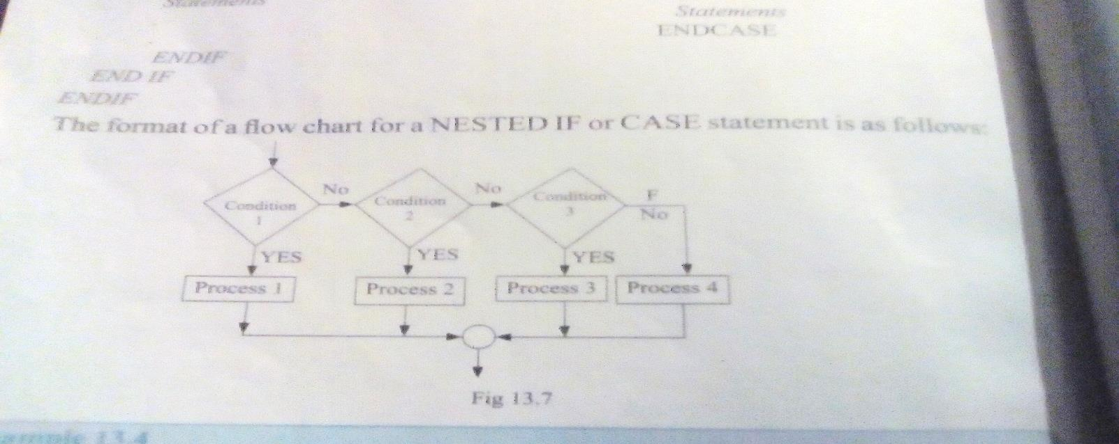  EXAMPLE  a. Draw the flow chart for a program that would categorize student’s performance in mathematics as follows  80 and above :excellent,60-79 Good ,40-59:Fair,0-39:poor  b. Write the pseudocode for the program in part (a) using  i)NESTED IF statement  ii)CASE statement  SSOLUTIONS  A.  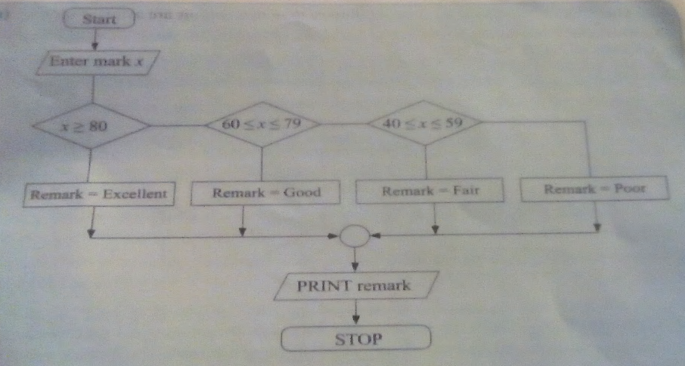  B. i)  Pseudecode in NESTED IF  START  ENTER marks x,  IF x60x70 THEN  Remark=Excellent  ELSE  IFx40x70THEN  Remark=Fair  ELSE  Remark=Poor  ENDIF  ENDIF  ENDIF  PRINT Remarks  STOP  B. II)  Pseudecode in CASE statement  START  ENTER marks x  CASE x of  x80:remark=Excellent  60x70:remarks=Good  40x59:remark=Fair  ELSE  Remark=Poor  ENDCASE | Teacher to explain about the NESTED IF Statement and allows learners to ask questions  Teacher to write the example on the board  Teacher to solve on the board | Learners to listen attentively and ask questions  Learners to write the examples in their exercise books | Teacher expositions  Demonstration  Demonstration
Lesson conclusion: Tr to conclude lesson by revising through the lesson with leaners to help remedial learners
Learners evaluation: ………………………………………………………………………………………………………………………………………………………………………………………………………………………………………………………………………………………………………………………………………………………………………………………………………………………………………………………………
Teachers evaluation:
………………………………………………………………………………………………………………………………………………………………………………………………………………………………………………………………………………………………………………………………………………………………………………………………………………………………………………………………

